# UNO Coin *User Guide*

**Integration Document**

*Version 1.0.1*

**Overview**

Unochat provides the recharging interface to facilitate the vending of the UNO coin.

This interface allows recharging the coin from coin merchant thru a single interface.

User can buy his coin by Credit Card. UnoCoin interface does not remember user’s card information, it is just make the payment for some coin.

**Add the coin exchanger in Service Accounts**

The user must be added “Coin Exchanger” to buy the coin in Service Accounts of the contacts.

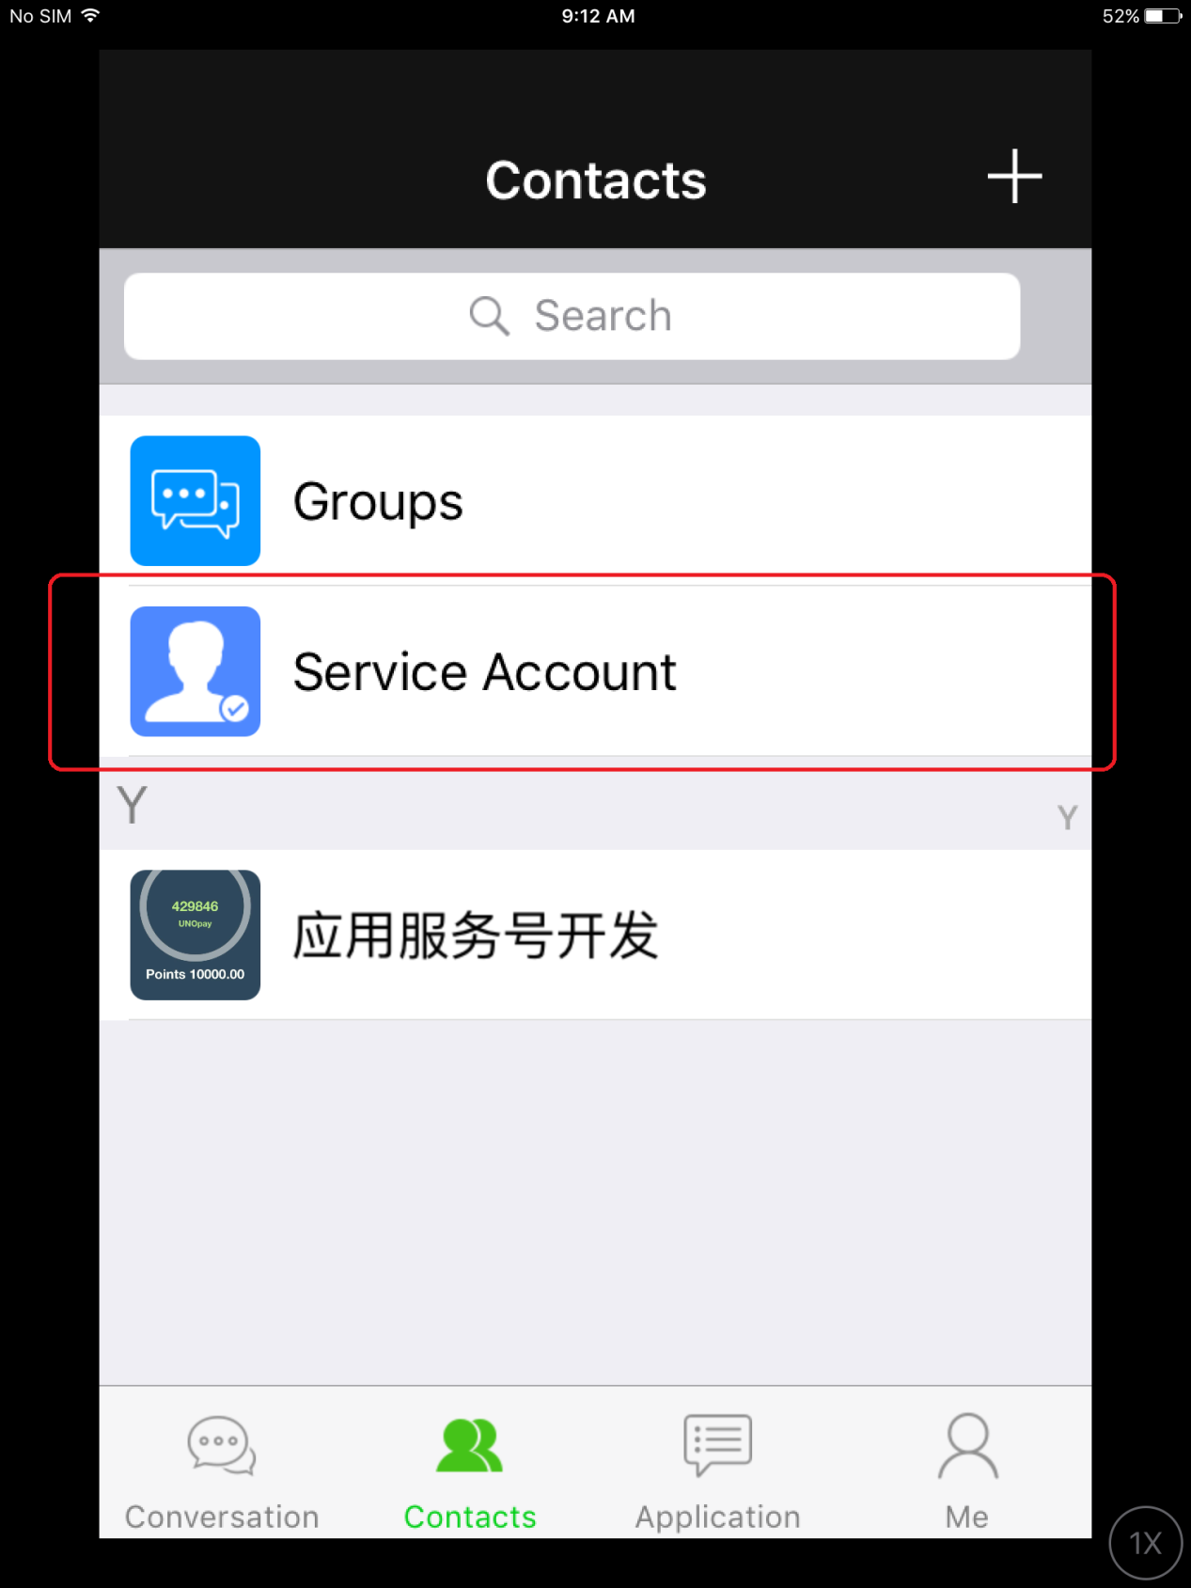

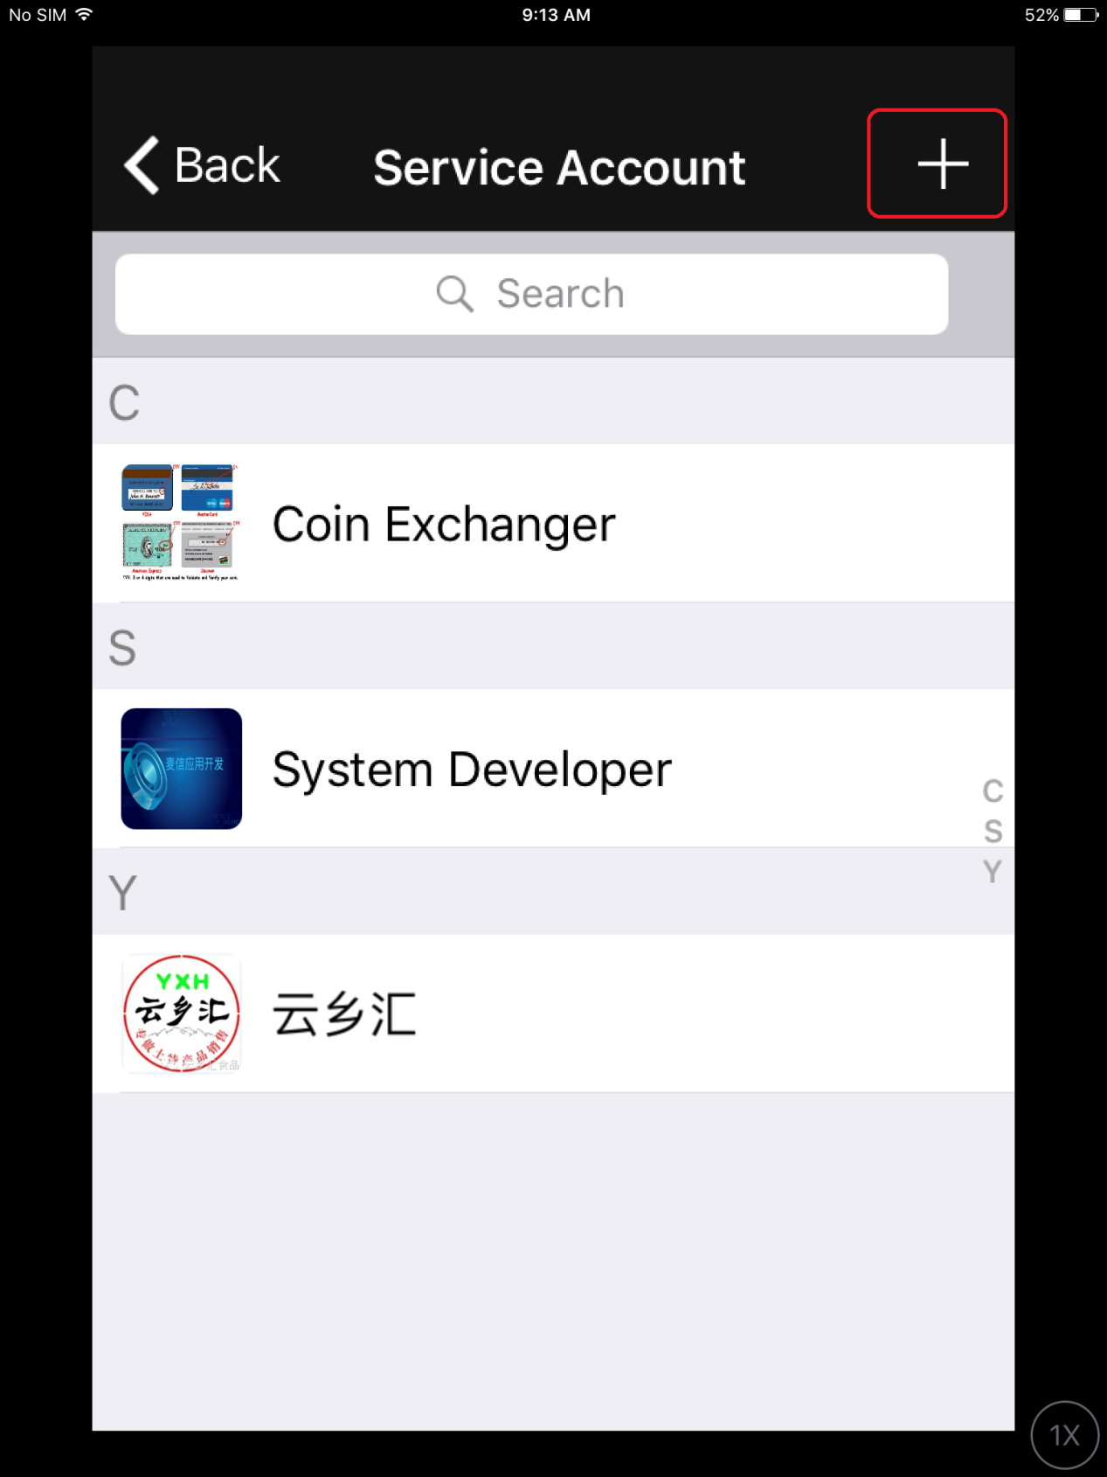

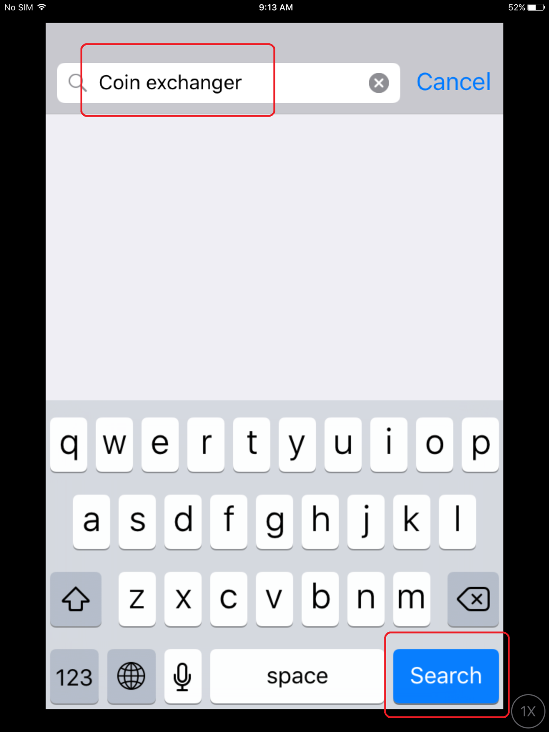

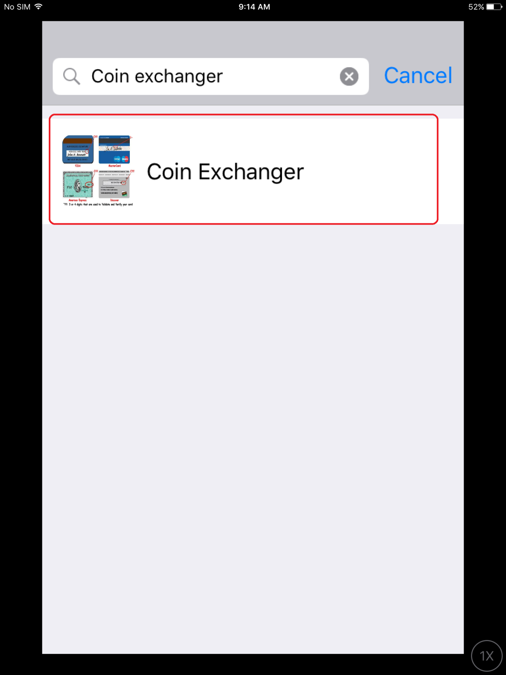

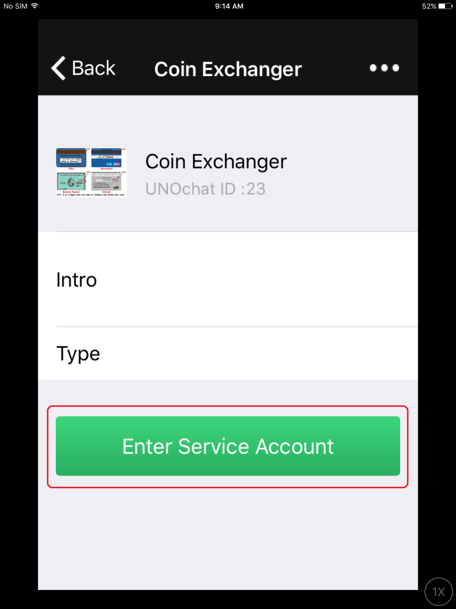

**Buy the coin**

The user can buy the coin When added Coin Exchanger in his Service Account of Contacts.



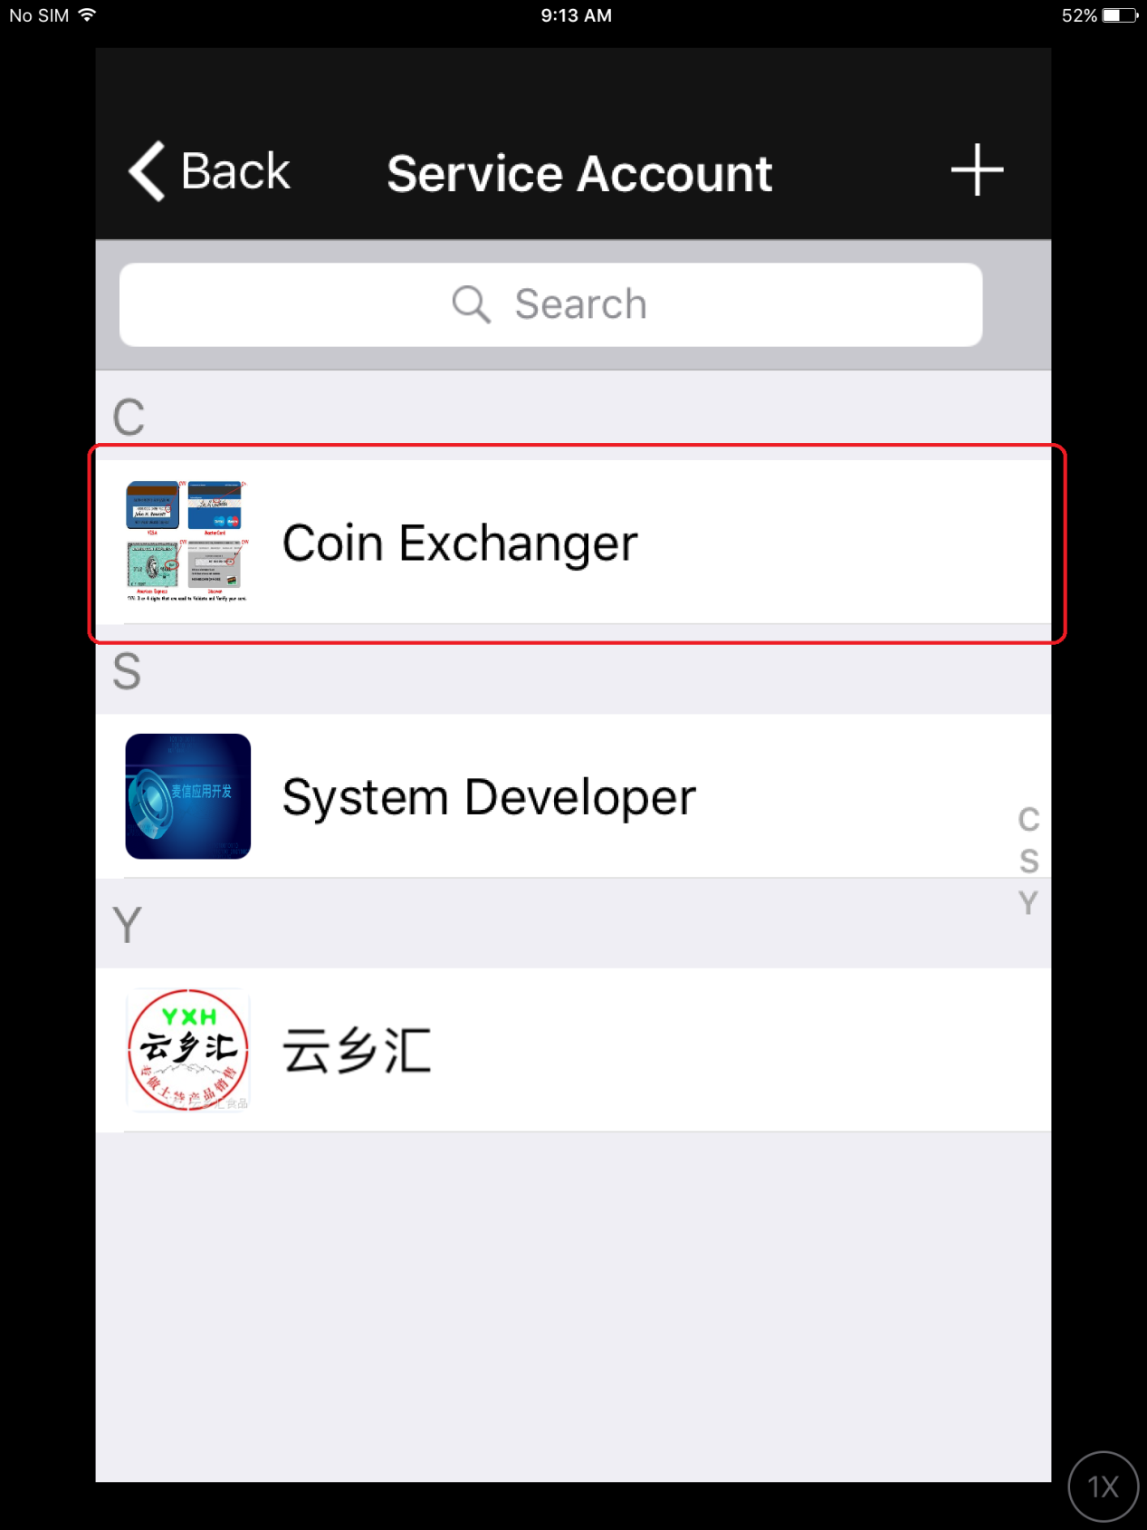

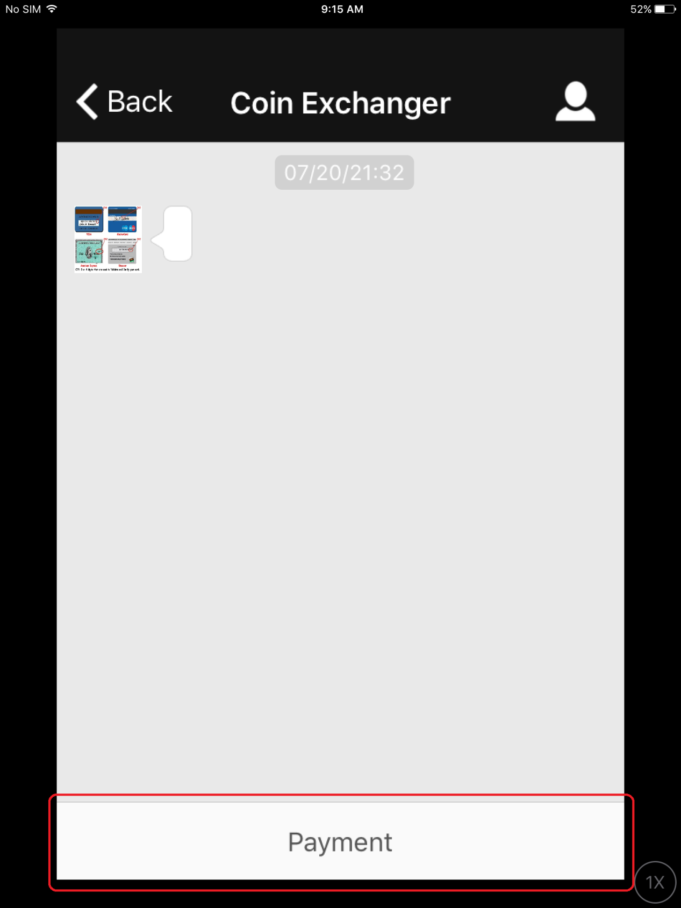

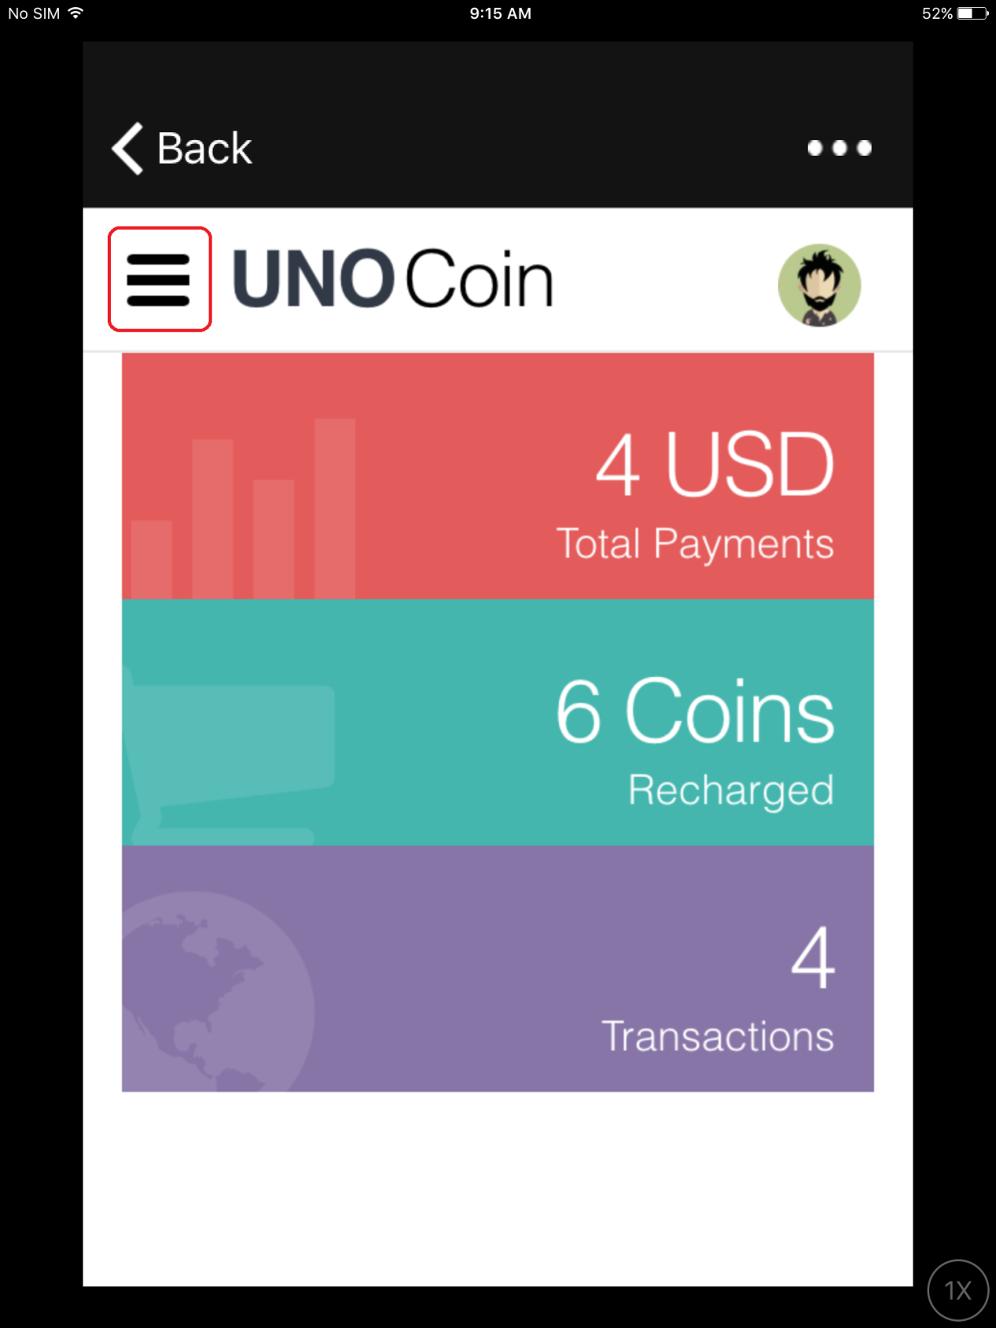

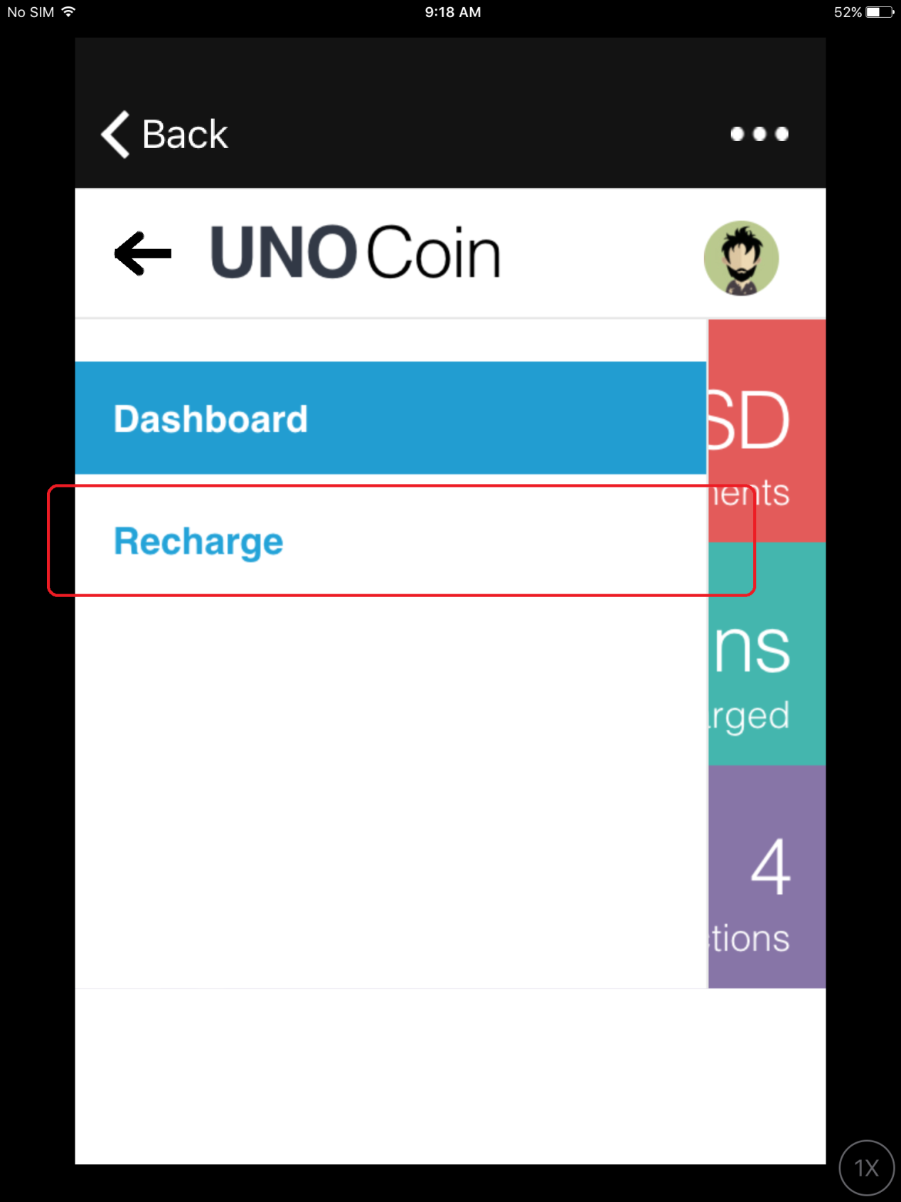

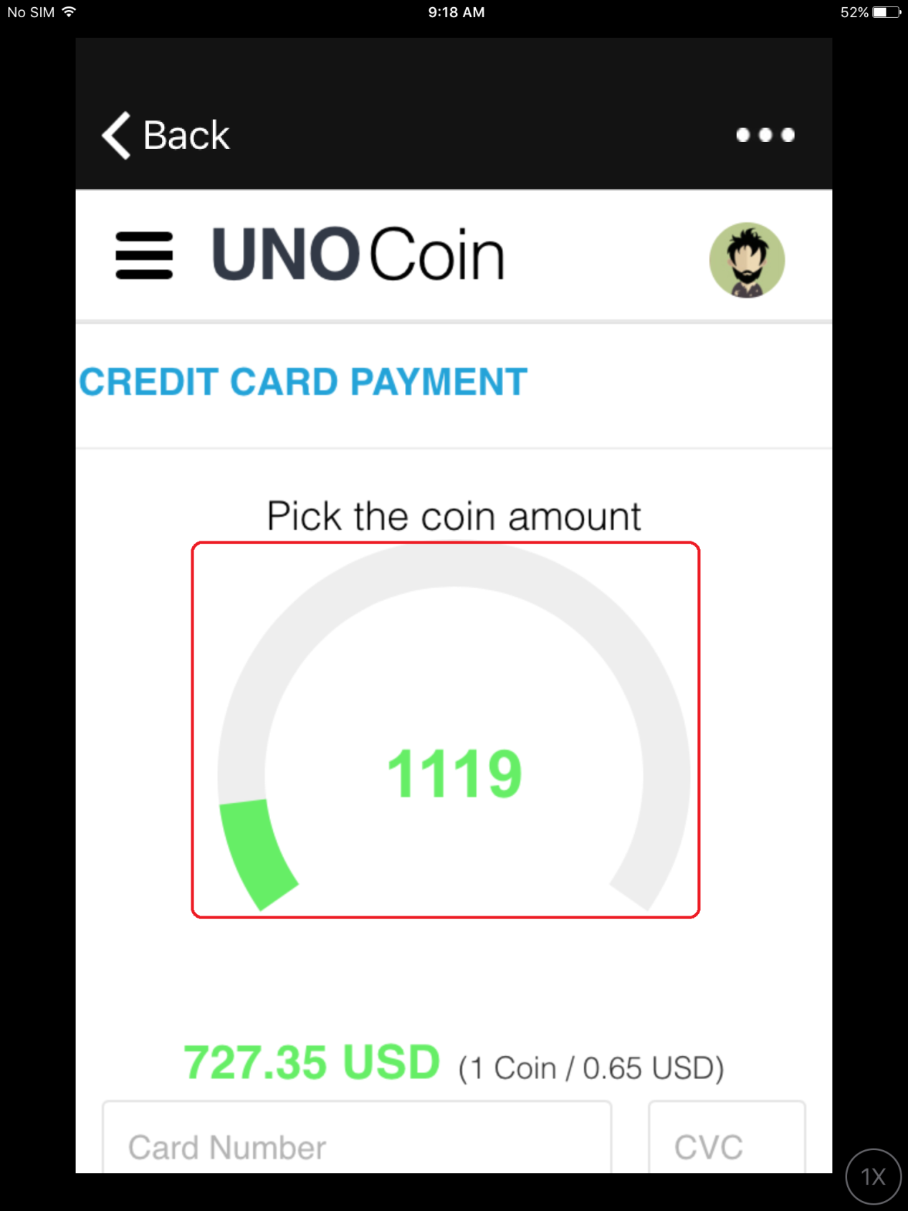

User can drag the bar to pick the coin amount. Also user can input the coin amount directly.

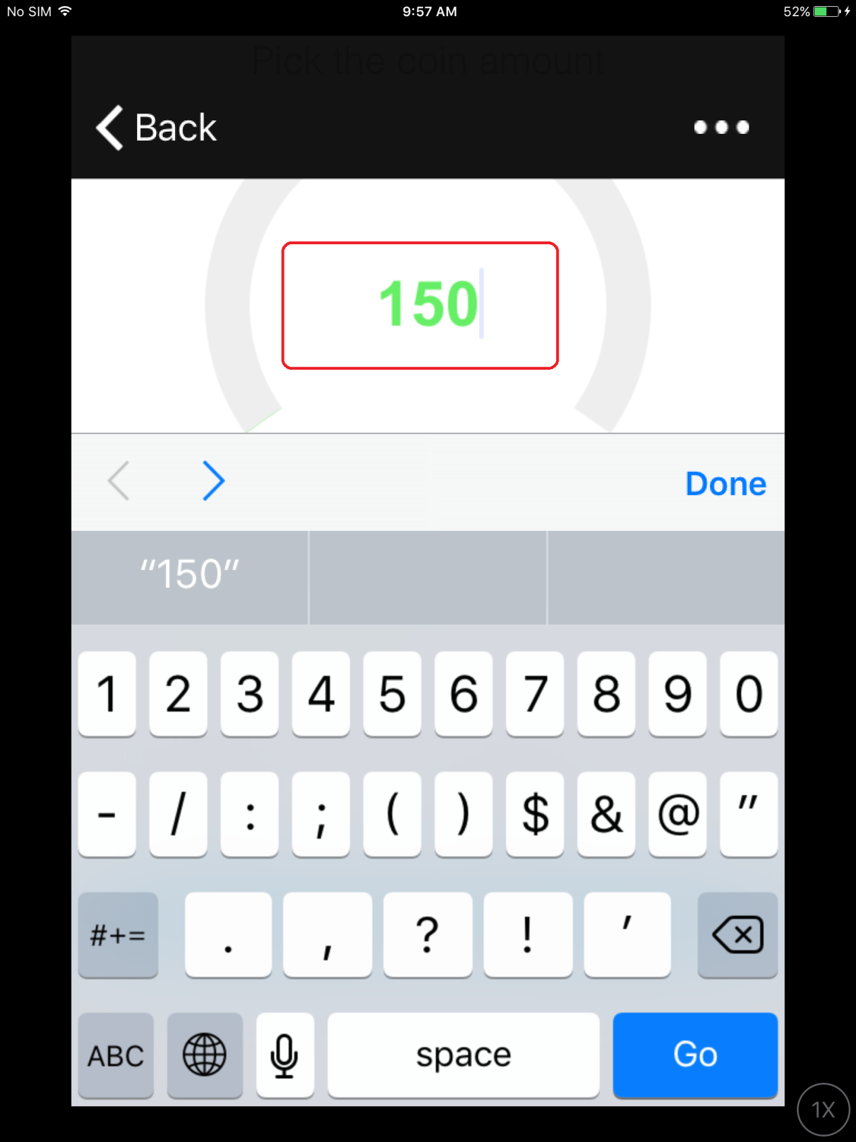

The user can check expected amount(USD) directly.

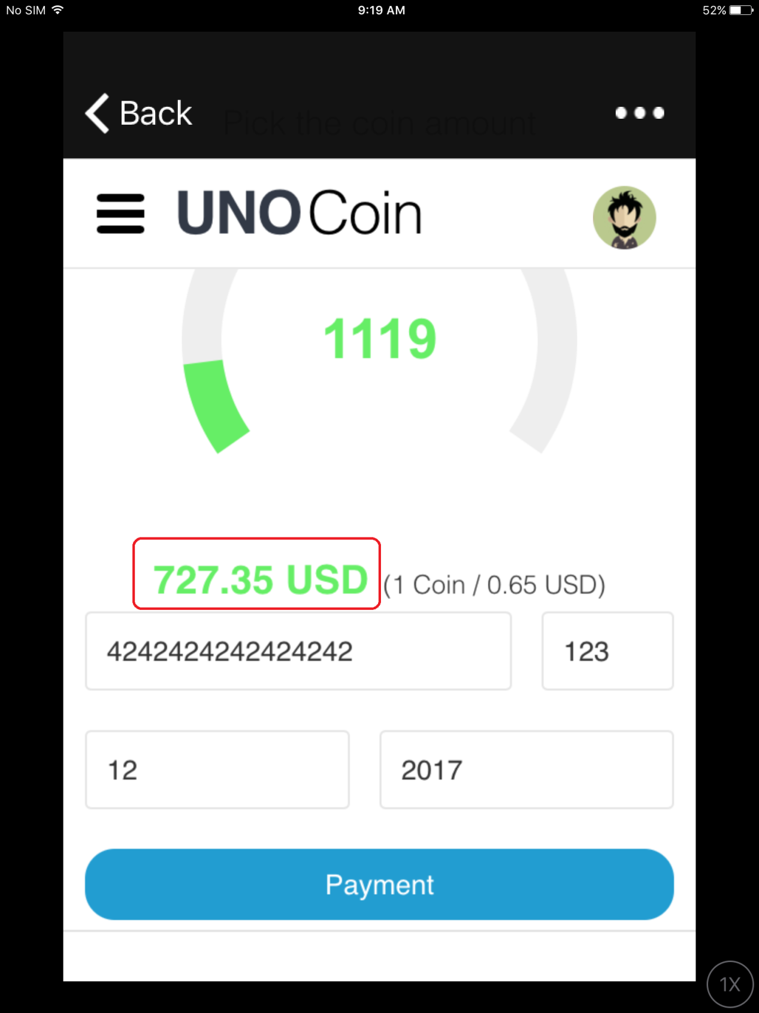

Finally, the user put his credit card information and click the button named “Payment”.

